
GRENADIER TRAINING REFERENCE
By Kevin

Table of Contents
- The Grenadier Role
  - What does it mean?
  - What does it bring to the section?
- The Grenade Launcher
  - Weapon overview
  - How to use the weapon
  - Ranging the weapon
- Determining Distance
  - Estimating range
  - Using the Vector Nite
- Ammunition Types
  - HE Grenade
  - HEDP Grenade
  - HET Grenade
  - Smoke Grenades
  - Illumination Flares
  - HuntIR Round
- Practical Exercises

The Grenadier role
A Grenadier is a rifleman first and a specialist second.
Your primary responsibility is to fight alongside your section as a standard infantryman. The grenade launcher is an additional capability that allows the section to engage targets that are behind or in cover. A good grenadier does not constantly fire grenades. Instead, they recognize when the grenade launcher provides the greatest tactical advantage and employ it at the correct moment.

What Does a Grenadier Bring to the Section?
The grenade launcher significantly increases the section's flexibility by allowing engagement of enemies in positions that would otherwise require heavier support.
As a Grenadier you can:
- Engage enemies behind walls, rocks, trenches, windows, and other cover using High Explosive (HE) grenades.
- Support assaults by deploying smoke to screen friendly movement.
- Suppress enemy positions with fragmentation effects.
- Mark enemy positions, landing zones, or objectives using coloured smoke.
- Illuminate dark areas using flare rounds during night operations.
- Provide limited anti-material or anti-light vehicle capability (depending on ammunition available).
- Assist the Section Commander by rapidly responding to changing battlefield conditions.
A well-trained grenadier can often solve problems before heavier support assets are required.

The Grenadier Mindset
A successful grenadier is always thinking ahead.
Before firing, ask yourself:
- Is a grenade the best tool for this target?
- Are friendly forces close to the impact area?
- Will this improve the section's current situation?
- Is there a safer firing angle?
- Will this create unnecessary collateral damage?

Safety and Rules of Engagement
Because explosive ammunition can cause significant damage over a wide area, the Grenadier must have an excellent understanding of the Rules of Engagement (ROE).
You are responsible for every round you fire.
Always consider:
- Friendly positions.
- Civilian presence.
- Collateral damage.
- Minimum safe distance.
- Risk of fragmentation.
- Risk of ricochet (particularly with HEDP ammunition).
Never fire simply because you have ammunition available.
Fire because the tactical situation requires it.

Communication
The Section Commander relies on the Grenadier to communicate effectively.
Before firing special ammunition, communicate your intentions whenever possible.

After firing, report the effects if visible.

Common Mistakes
New Grenadiers often:
- Fire too many HE rounds.
- Forget they are still riflemen.
- Ignore minimum engagement distances.
- Fail to communicate before firing.
- Waste smoke without supporting movement.
- Fire at single exposed targets instead of groups or covered enemies.
- Forget to carry the correct ammunition for the mission.
A disciplined Grenadier is far more valuable than one who simply fires the most grenades.

Questions for Trainees
Ask the trainees the following questions throughout the lesson:
- What is the Grenadier's primary role?
- When should HE grenades be used instead of rifle fire?
- When should smoke be deployed?
- Why is communication important before firing explosive rounds?
- What risks should you consider before firing?
- When can a Grenadier freely employ grenades, and when is authorisation required?
- What dangers exist when friendlies are close to the target?
- Why is range estimation important?
These questions help reinforce decision making and not just the text we teach them.

How to Use the Weapon
The method of using the grenade launcher depends on the type of launcher you are equipped with.

Underbarrel Grenade Launcher (MK 18 mod 1 M 320)
If your grenade launcher is mounted underneath your rifle, switch to the launcher by cycling your weapon's fire mode until the grenade launcher is selected.

Standalone Grenade Launcher (M329 GLM)
If you are carrying a standalone grenade launcher as your secondary weapon, simply switch to your secondary weapon. No fire mode change is required.
Once the launcher is selected:
- Determine the range to your target.
- Set the correct range on your sights.
- Aim using the grenade launcher's sight.
- Fire and observe the impact.
- Adjust your range if necessary before firing another round.

Ranging the Weapon
The grenade launcher sight can be adjusted to match the distance to your target.

Adjusting the Sight
- Page Up (PgUp) – Increase the range.
- Page Down (PgDn) – Decrease the range.
- Ctrl + Scroll wheel
As you adjust the sight, the aiming reticle will move to compensate for the projectile's trajectory.
The selected range is displayed in the top-right corner of your screen.
The numbers shown represent the approximate distance, in metres, that the grenade is expected to travel.
Always set the sight as close as possible to the measured distance before engaging.
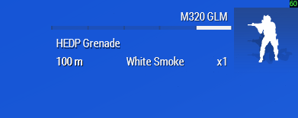

Determining the Range
Accurate range estimation is essential for effective grenade launcher employment.
Several methods can be used to determine the distance to a target.

Visual Estimation
Estimate the distance using terrain features and known reference points, such as roads, buildings, or tree lines.
You can also use your map and grid references to estimate the distance between your position and the target.

Using the Android Device
If the enemy's position is known, the in-game Android device can be used to determine the range.
The distance to the selected marker or position is displayed in the bottom-left corner of the Android interface.
This provides a quick and reliable way to determine your sight setting before engaging.

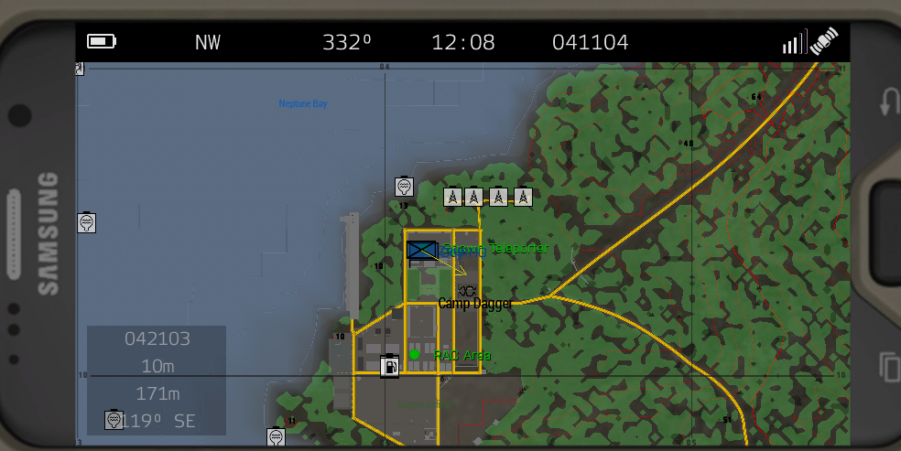

Using the Vector 21 Nite
The Vector 21 Nite is the most accurate method of determining distance.
It is equipped in your Binoculars slot.

Procedure
- Equip the Vector 21 Nite.
- Aim at the target.
- Press “R”
- The range will be on the right side

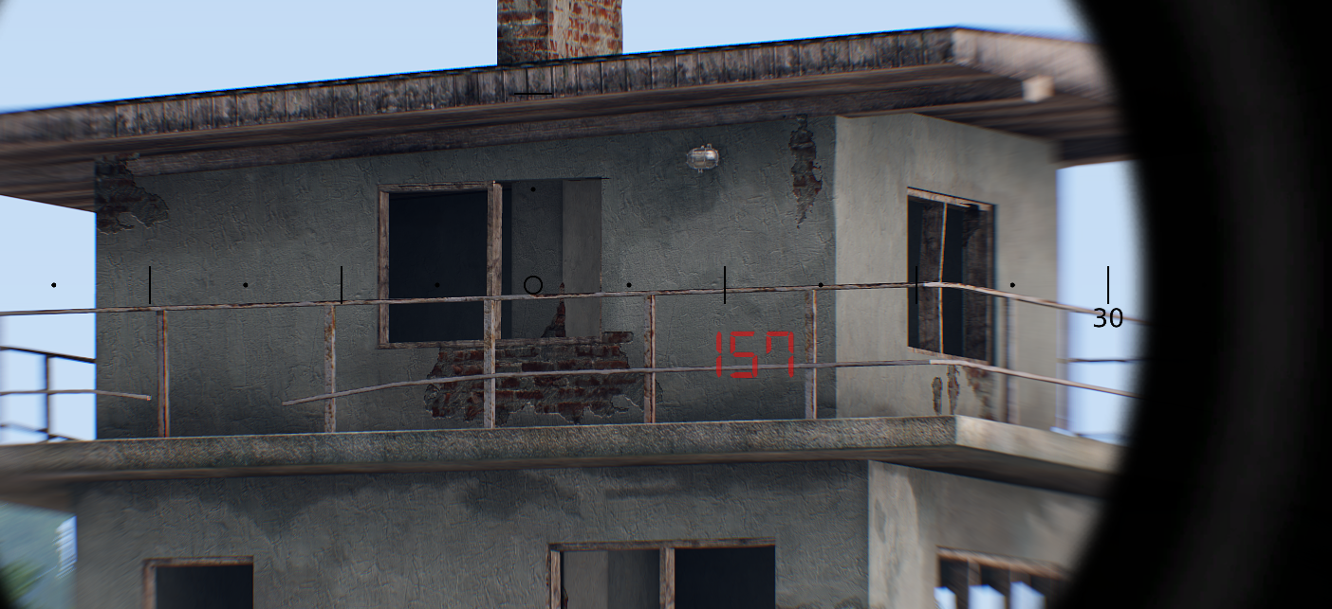

Ammunition Types
Selecting the correct ammunition is just as important as accurate shooting. Each round has a specific purpose and should be used appropriately.

HE Grenade (High Explosive)
Purpose: Standard anti-personnel round.
Best Used Against:
- Infantry
- Enemy groups
- Trenches
- Positions behind cover
Advantages:
- Effective fragmentation
- Good for suppression

HEDP Grenade (High Explosive Dual Purpose)
Purpose: Anti-personnel and light anti-vehicle round.
Best Used Against:
- Light vehicles
- Fortifications
- Infantry behind light cover
Advantages:
- Versatile ammunition
- Can damage light armour while remaining effective against personnel

HET Grenade (High Explosive Timed)
Purpose: Airburst grenade that detonates after a programmed time in flight.
Best Used Against:
- Enemies behind walls
- Defilade positions
- Trenches
- Targets in light cover
Advantages:
- Airburst effect increases the chance of hitting enemies protected by cover
- Can engage targets that standard HE rounds may not reach effectively
*Special note *
This grenade is automatically set it fuze when ranging

Smoke Grenades
Purpose: Conceal movement or mark locations.
Common Uses:
- Screen friendly movement
- Conceal casualty evacuation
- Mark enemy positions
- Mark objectives or landing zones

INCASE OF NOBODY KNOWING A REMINDER

Red smoke - Opfor/enemies

Blue smoke - HLS

Green smoke - Friendlies

Yellow smoke - Casualty collection point

Purple smoke - Mascas Mascas Mascas

Illumination Flares
Purpose: Provide light during low-light or night operations.
Common Uses:
- Illuminate enemy positions
- Observe terrain
- Support night operations
Remember that illumination reveals both enemy and friendly forces.

HuntIR Round
Purpose: Conduct aerial reconnaissance.
Common Uses:
- Scout compounds
- Observe behind hills or buildings
- Identify enemy positions before advancing
The HuntIR round provides valuable intelligence while reducing the need to expose friendly forces.

Using the HuntIR Monitor
The HuntIR system consists of two components:
- HuntIR 40 mm Round
- HuntIR Monitor
The HuntIR round launches a camera suspended beneath a parachute, providing live aerial reconnaissance of the target area.

Employment
- Load a HuntIR round into your grenade launcher.
- Aim high above the area you wish to observe.
- Fire the round.
- Open the HuntIR Monitor using the ACE Self Interaction menu:
  - Ctrl + Windows Key (default ACE keybind)
  - Equipment
  - Activate HuntIR Monitor
- The monitor will automatically connect to the most recently

HuntIR Monitor Controls
Key | Function
← / → | Rotate camera left / right
↑ / ↓ | Tilt camera up / down
A | Zoom out
D | Zoom in
N | Toggle Night Vision
W | Previous camera
S | Next camera
R | Reset camera position
Esc | Close the HuntIR Monitor

Best Practices
- Fire the round at a high angle (45° or greater) to maximise observation time.
- Consider the wind, as it will move the parachute and camera.
- Use the HuntIR before entering compounds, crossing open terrain, or approaching suspected enemy positions.
- Relay any observations to the Section Commander immediately.
- Multiple HuntIR rounds can be airborne simultaneously, allowing you to switch between cameras.

Limitations
- The HuntIR camera remains airborne only while the parachute is deployed.
- Strong winds can move the camera away from the intended observation area.
- The monitor can only connect to HuntIR cameras that are within transmission range.

Practical Exercise
The practical exercise is designed to familiarise trainees with the grenade launcher, range estimation, ammunition selection, and engaging targets under different conditions.
The training server contains a Grenadier Firing Range that can be accessed via the teleport menu.

Exercise 1 – Basic Marksmanship
Location: Left Firing Range
Objective:
Practice ranging the grenade launcher and engaging stationary targets.
Tasks:
- Determine the distance to each target.
- Set the correct sight range.
- Engage each target with accurate fire.
- Adjust subsequent rounds if required.
Performance Standard:
The trainee should consistently achieve first- or second-round hits while demonstrating correct ranging procedures.

Exercise 2 – Target Engagement
Location: Right Firing Range
The right side of the range contains two lanes with targets positioned behind various types of cover and concealment.
Objective:
Develop the ability to select the correct ammunition and engage targets based on the tactical situation.
Tasks:
- Determine the distance to each target.
- Identify the type of cover protecting the target.
- Select the most appropriate ammunition.
- Engage the target while considering the effects of the chosen round.
- Explain your ammunition choice before firing.
Performance Standard:
The trainee should demonstrate:
- Accurate range estimation.
- Correct use of the grenade launcher sights.
- Appropriate ammunition selection.
- Safe employment of explosive rounds.
- Good judgement when engaging targets behind cover.

Instructor Considerations
During the exercise, instructors should assess the trainee's ability to:
- Estimate or determine target range.
- Correctly range the grenade launcher.
- Select the appropriate ammunition for each target.
- Understand the strengths and limitations of each ammunition type.
- Maintain awareness of friendly forces and potential collateral damage.
- Communicate their intended actions before engaging.
The emphasis of this exercise is not simply hitting the target, but demonstrating sound tactical decision-making and safe employment of the grenade launcher.

